**UNIT II**

**Software Test Automation:** Fundamentals of Test Automation, Design and Architecture for Automation, Robotic Process Automation: An Introduction, Challenges in Automation

Introduction to Selenium, Components of Selenium, Advantages and Disadvantages of Selenium, Installation of Selenium IDE & Firebug Add – on, Writing the Test Cases, Selenium Commands, Assert, Verify, Locators, Enhancements, Variables, Echo, Alert and Popup.

**Software Test Automation:** Developing software to test the software is called test automation.

Test automation can help address several problems

1. Automation saves time as software can execute test cases faster than humans do
2. Test automation can free the test engineers from mundane tasks and make them focus on more creative tasks
3. Automated tests can be more reliable
4. Automation helps in immediate testing
5. Automation can protect an organization against attrition of test engineers
6. Test automation opens up opportunities for better utilization of global resources
7. Certain types of testing cannot be executed without automation
8. Automation means end - to – end, not test execution alone

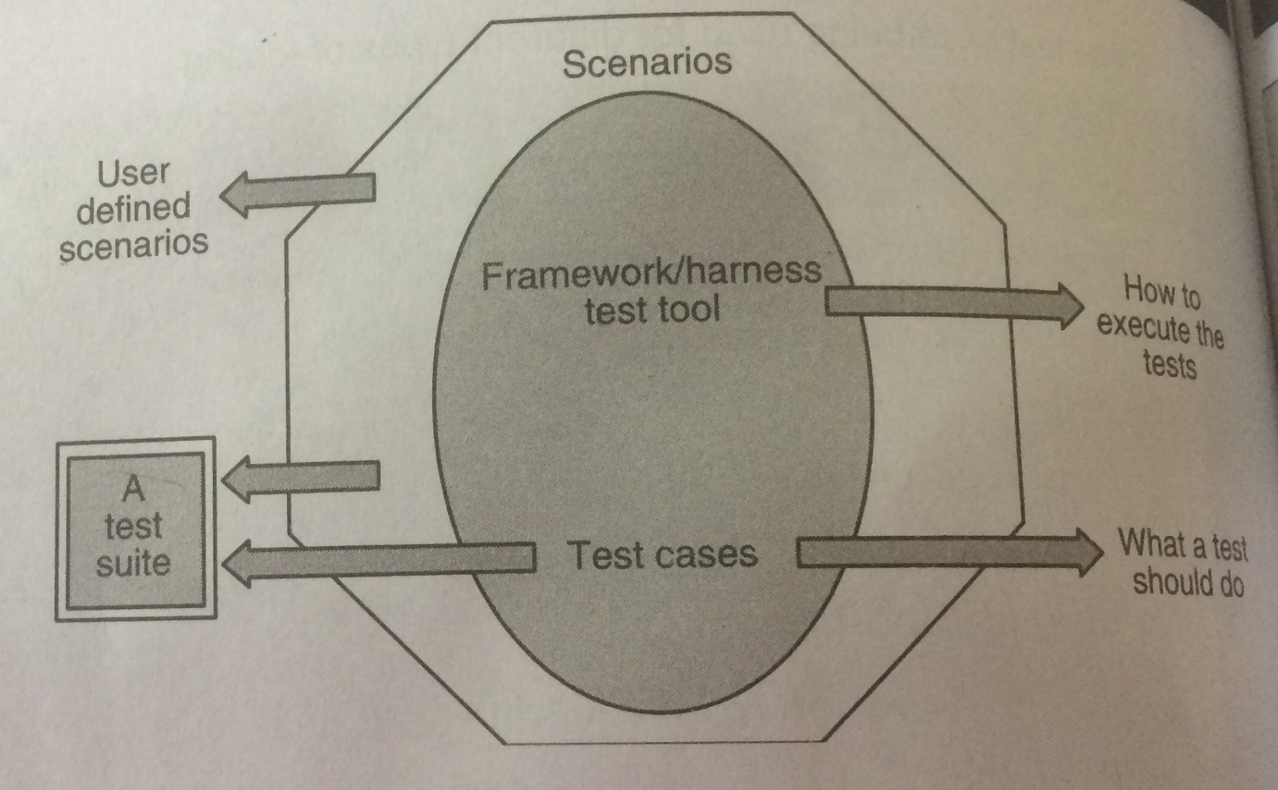

**Framework for Test Automation**

**Design and Architecture for Automation**

**Components of Test Automation: -**

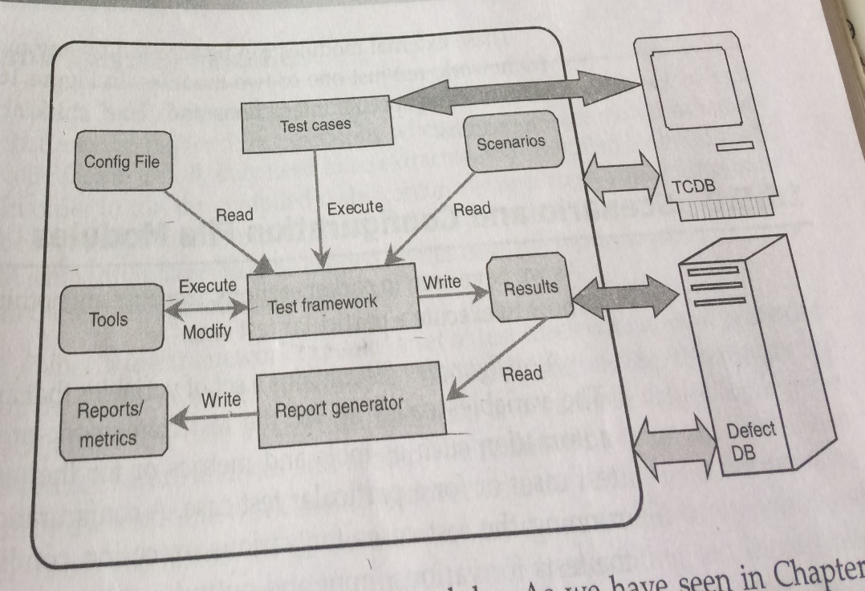

**Robotic Process Automation: The Next Transformation Lever for Shared Services**

Robotic process automation (RPA) is the application of technology that allows employees in a company to configure computer software or a “robot” to capture and interpret existing applications for processing a transaction, manipulating data, triggering responses and communicating with other digital systems.

Any company that uses labor on a large scale for general knowledge process work, where people are performing high-volume, highly transactional process functions, will boost their capabilities and save money and time with robotic process automation software.

Robotic Process Automation is the technology that allows anyone today to configure computer software, or a “robot” to emulate and integrate the actions of a human interacting within digital systems to execute a business process. RPA robots utilize the user interface to capture data and manipulate applications just like humans do. They interpret, trigger responses and communicate with other systems in order to perform on a vast variety of repetitive tasks. Only substantially better: an RPA software robot never sleeps, makes zero mistakes and costs a lot less than an employee.

**How is RPA different from other enterprise automation tools?**

In contrast to other, traditional IT solutions, RPA allows organizations to automate at a fraction of the cost and time previously encountered. RPA is also non-intrusive in nature and leverages the existing infrastructure without causing disruption to underlying systems, which would be difficult and costly to replace. With RPA, cost efficiency and compliance are no longer an operating cost but a byproduct of the automation.

* Fast benefit realization
* Minimal upfront investment
* No disruption to underlying systems
* Led by the business, with support from IT
* Highly scalable, adapts to changing business environment

**How does Robotic Process Automation work?**

RPA robots are capable of mimicking many–if not most–human user actions. They log into applications, move files and folders, copy and paste data, fill in forms, extract structured and semi-structured data from documents, scrape browsers, and more.

1. Log into any application
2. Connect to system APIs
3. Copy and paste data
4. Move files and folders
5. Extract and process structured and semi structured content from documents, PDFs, emails and forms
6. Read and write to databases
7. Opens emails and attachments
8. Scrape data from the web
9. Make calculations

**RPA Life Cycle**

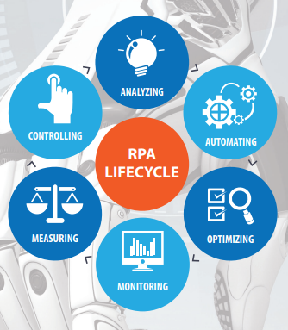

**What processes are relevant to RPA?**

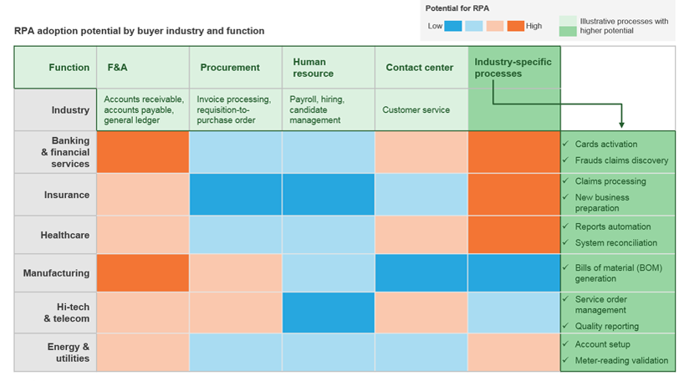

**What are the business benefits of RPA?**

Robots are here to stay. The faster you harvest their potential, the faster you create a competitive edge for your business. Robotic Process Automation delivers direct profitability while improving accuracy across organizations and industries. Enabling RPA to handle any processes will not only transform and streamline your organization’s workflow. It will allow for superior scalability and flexibility within the enterprise, doubled by fast, tailored response to specific needs. Software robots are easy to train and they integrate seamlessly into any system. Multiply them, and instantly deploy more as you go. They constantly report on their progress so you can go even bigger and better by using operational and business predictability, while improving strategically.

* Better accuracy: - Robotic Process Automation software robots are programmed to follow rules. They never get tired and never make mistakes. They are compliant and consistent.
* Improved compliance: - Once instructed, RPA robots execute reliably, reducing risk. Everything they do is monitored. You have the full control to operate in accordance with existing regulations and standards.
* Fast cost savings: -RPA can reduce processing costs by up to 80%. In less than 12 months, most enterprises already have a positive return on investment, and potential further accumulative cost reductions can reach 20% in time.
* Super scalable: - Across business units and geographies, RPA performs a massive amount of operations in parallel, from desktop to cloud environments. Additional robots can be deployed quickly with minimal costs, according to work flux and seasonality.
* Increased speed and productivity: - Employees are the first to appreciate the benefits of RPA as it removes non-value-add activities and relieves them from the rising pressure of work.

**Difference between RPA and AI**

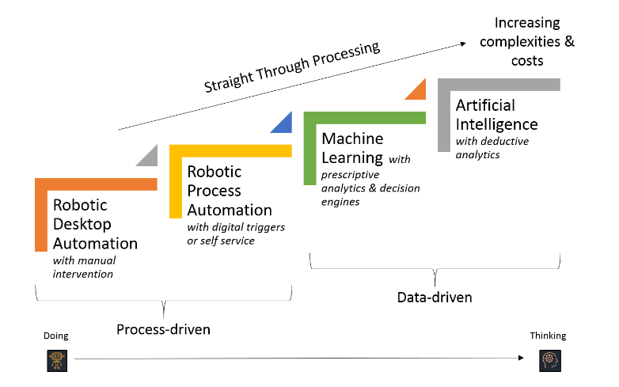

**Use Cases of RPA:**

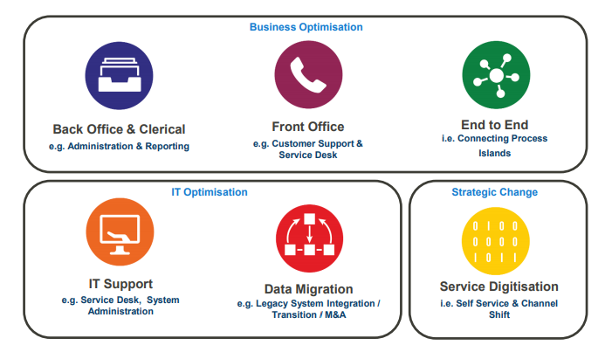

**Introduction to Selenium: What is Selenium?**

* Selenium is a free (open source) automated testing suite for web applications across different browsers and platforms.
* Selenium is not just a single tool but a set of tools that helps testers to automate web-based applications more efficiently.

**Selenium Suite**

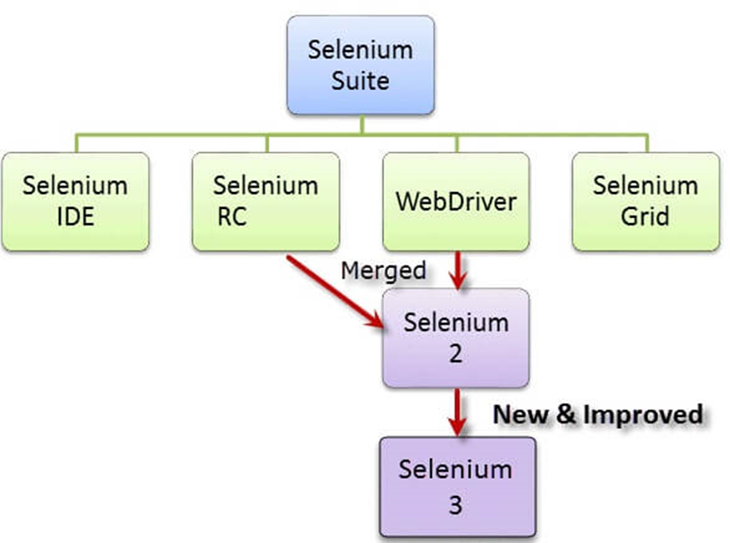

**Components of selenium**

|  |  |  |
| --- | --- | --- |
| **S. No.** | **Tool** | **Description** |
|  | Selenium IDE | Selenium Integrated Development Environment (IDE) is a Firefox plugin that lets testers to record their actions as they follow the workflow that they need to test. |
|  | Selenium RC | Selenium Remote Control (RC) was the flagship testing framework that allowed more than simple browser actions and linear execution. It makes use of the full power of programming languages such as Java, C#, PHP, Python, Ruby and PERL to create more complex tests. |
|  | Selenium Web Driver | Selenium Web Driver is the successor to Selenium RC which sends commands directly to the browser and retrieves results. |
|  | Selenium Grid | Selenium Grid is a tool used to run parallel tests across different machines and different browsers simultaneously which results in minimized execution time. |

**Advantages of selenium**

* Selenium is an open-source tool.
* Can be extended for various technologies that expose DOM.
* Has capabilities to execute scripts across different browsers.
* Can execute scripts on various operating systems.
* Supports mobile devices.
* Can execute tests in parallel with the use of Selenium Grids.

**Disadvantages of selenium**

* Supports only web based applications.
* No feature such as Object Repository/Recovery Scenario
* No IDE, so the script development won't be as fast as QTP.
* No default test report generation.
* For parameterization, users has to rely on the programming language.

**How to Install Selenium IDE**

What you need

* Mozilla Firefox
* Active Internet Connection
* NOTE: - Selenium IDE is no longer compatible with Firefox 55 and above.

**How To Install Selenium IDE**

**Steps 1:** Launch Firefox and navigate to https://addons.mozilla.org/en-US/firefox/addon/selenium-ide/. Click on Add to Firefox

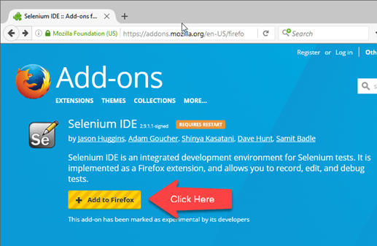

**Steps 2:** Wait until Firefox completes the download and then click "Install."

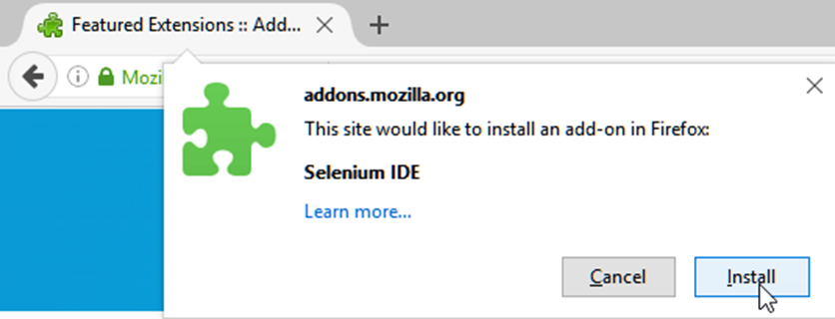

**Steps 3:** Wait until the installation is completed. In the pop-up window, click "Restart Now."

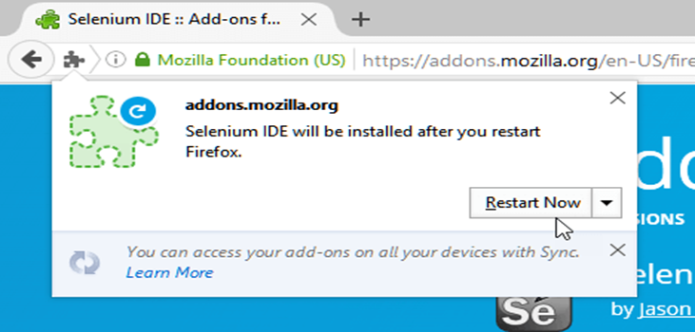

**Steps 4:** After Firefox has restarted, launch Selenium IDE using either of two ways:

* By pressing Ctrl+Alt+S
* By clicking on the Firefox menu button> Developer>Selenium IDE

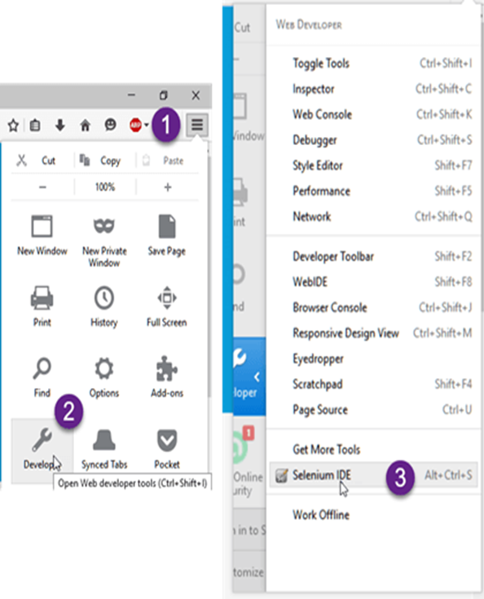

**Steps 5:** Selenium IDE should launch as shown below

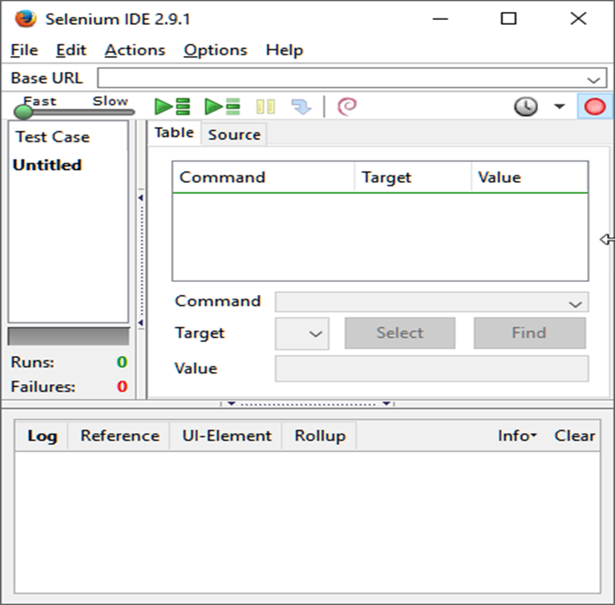

**Installation of Firebug**

* Firebug is a Firefox add-on that we will use to inspect the HTML elements of the web application under test.
* It will provide us the name of the element that our Selenese command would act upon.

**Step 1:** Use Firefox to navigate to Firebug's download page (https://addons.mozilla.org/en-US/firefox/addon/firebug/) and click on the download link.

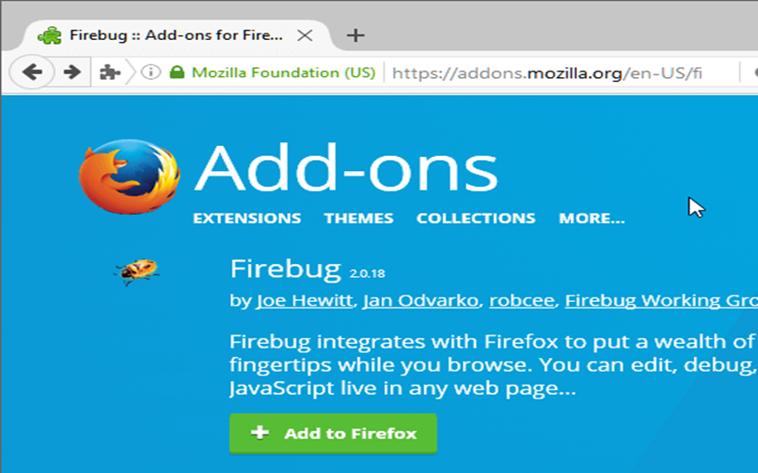

**Step 2:** Wait for Firefox to complete downloading this add-on. On the dialog box that comes after, click "Install Now."

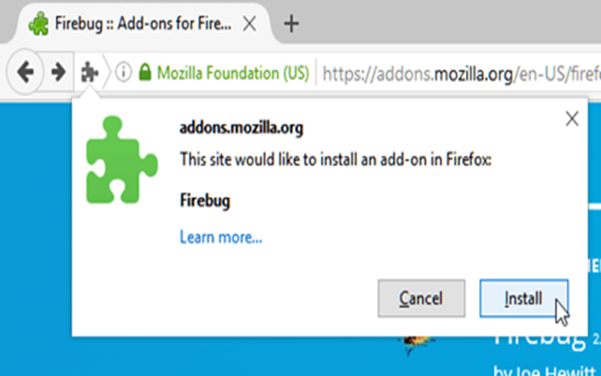

**Step 3:** Wait for the installation to complete. A notification will pop-up saying, "Firebug has been installed successfully." You can immediately close this pop-up.

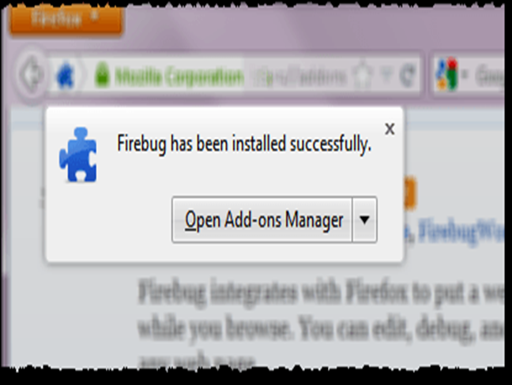

**Step 4:** Launch Firebug by doing either of these two methods:

* Press F12
* Click on the Firebug button in the upper right corner of the Firefox window.

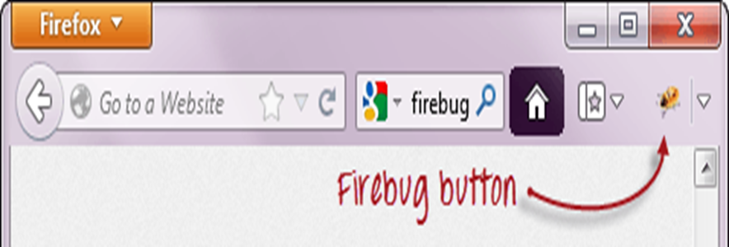

**Step 5:** Firebug should launch at the bottom of Firefox as shown below

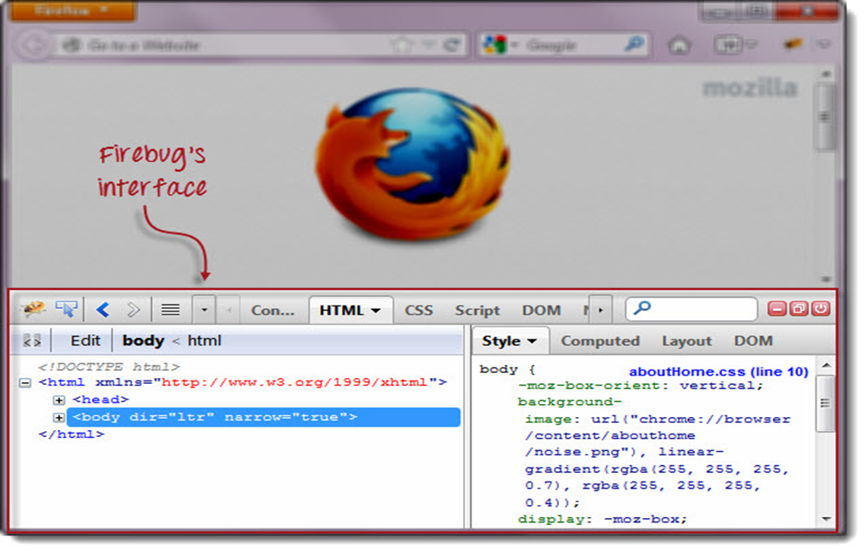

**Selenium IDE**

* The Selenium-IDE (Integrated Development Environment) is an easy-to-use Firefox plug-in to develop Selenium test cases.
* It provides a Graphical User Interface for recording user actions using.
* But it can only be used with Firefox browser as other browsers are not supported.
* However, the recorded scripts can be converted into various programming languages supported by Selenium and the scripts can be executed on other browsers as well.

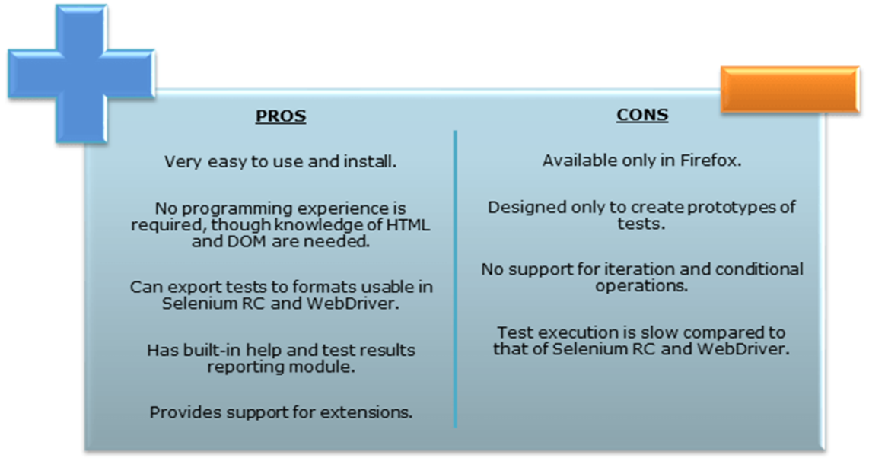

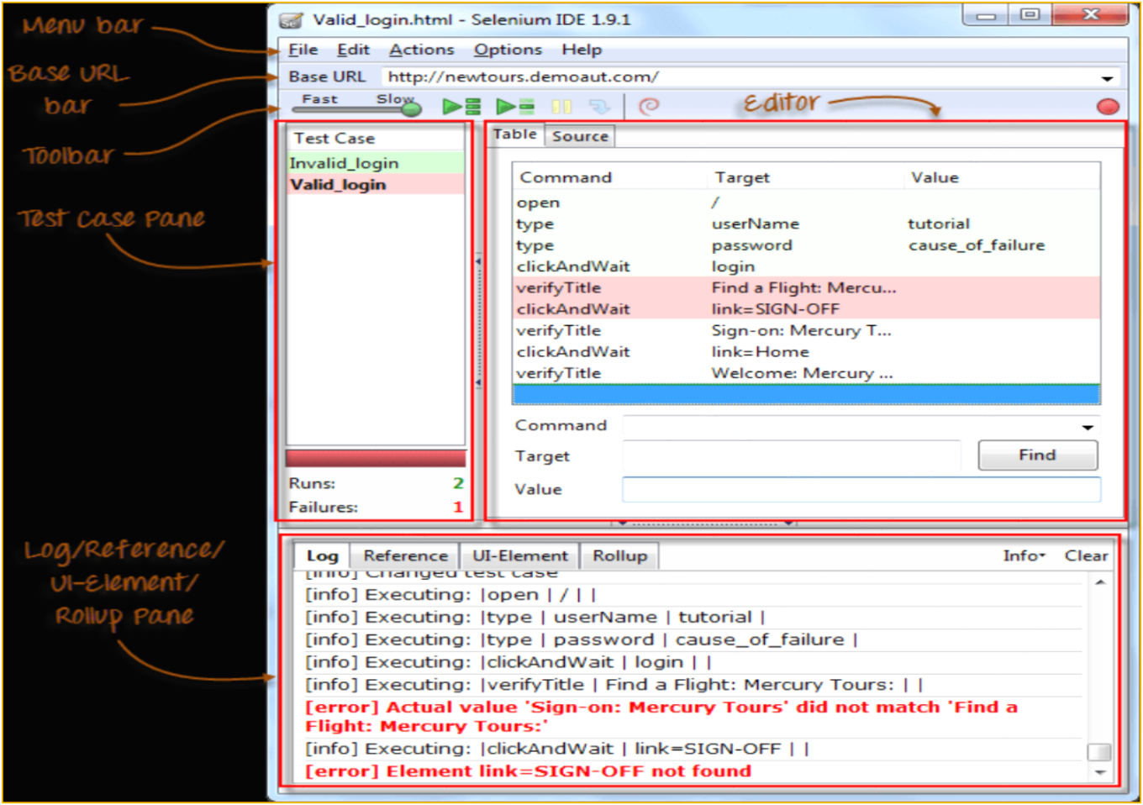

* **Menu Bar**

It is located at the **top most portion** of the IDE. The most commonly used menus are the File, Edit, and Options menus.

* + **File menu**

It contains options to create, open, save and close tests.

Tests are **saved in HTML format**.

* + - The most useful option is "**Export"** because **it allows you to turn your Selenium IDE test cases into file formats that can run on Selenium Remote Control and WebDriver**
    - **"Export Test Case As..."**will export only the currently opened test case.
    - **"Export Test Suite As..."**will export all the test cases in the currently opened test suite.

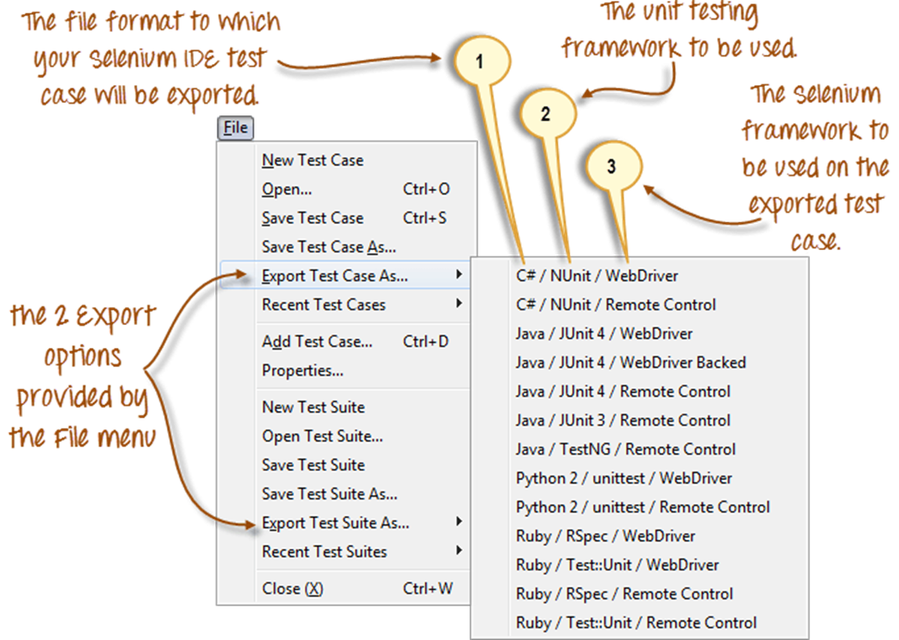

As of Selenium IDE v1.9.1, test cases can be exported only to the following formats:

.cs (C# source code)

.java (Java source code)

.py (Python source code)

.rb (Ruby source code)

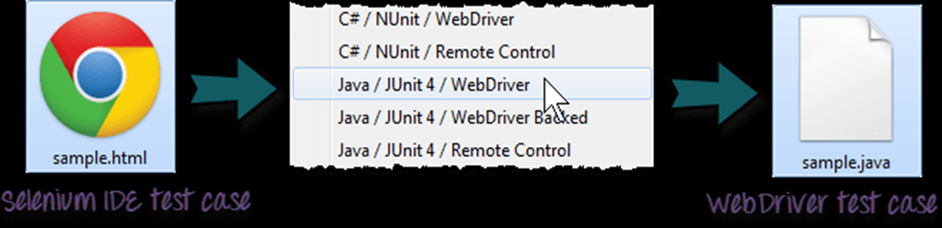

* + **Edit Menu**

It contains usual options like Undo, Redo, Cut, Copy, Paste, Delete, and Select All.

The two most important options are the "Insert New Command" and "Insert New Comment".

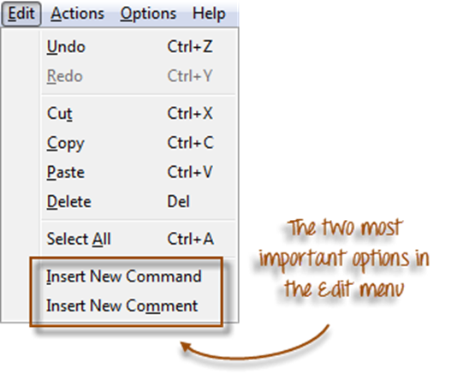

* + **Toolbar**

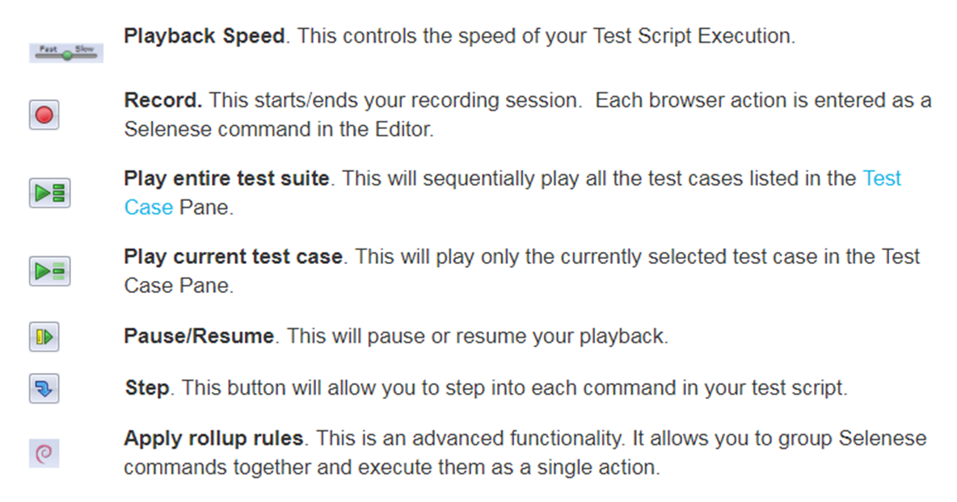

* + **Test Case Pane**

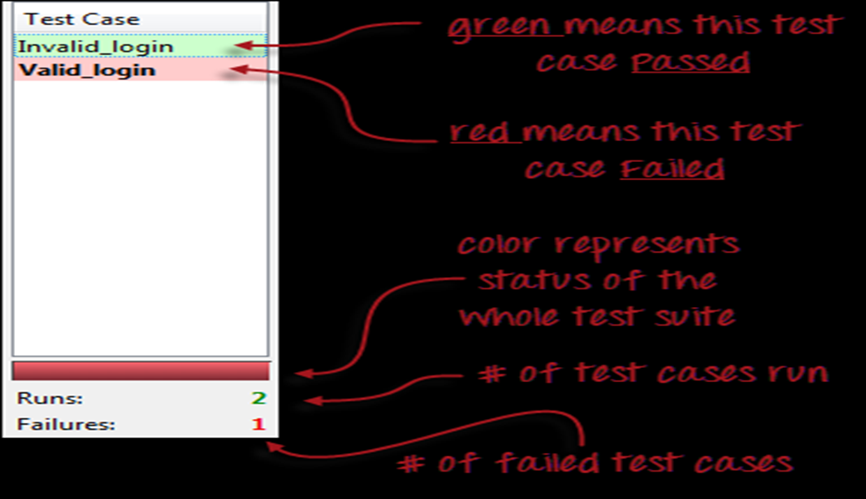

* + **Editor**

You can think of the editor as the place where all the action happens. It is available in two views: Table and Source.

* + **Table View**
    - Most of the time, you will work on Selenium IDE using the Table View.
    - This is where you create and modify Selenese commands.
    - After playback, each step is color-coded.

**Table View**

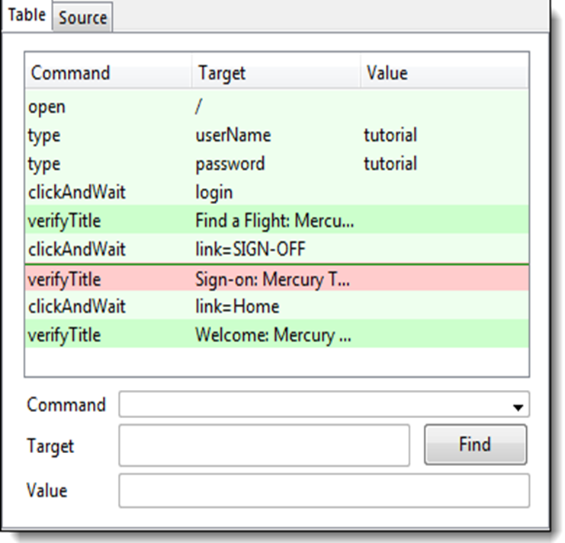

**Source View**

* + It displays the steps in HTML (default) format.
  + It also allows you to edit your script just like in the Table View.

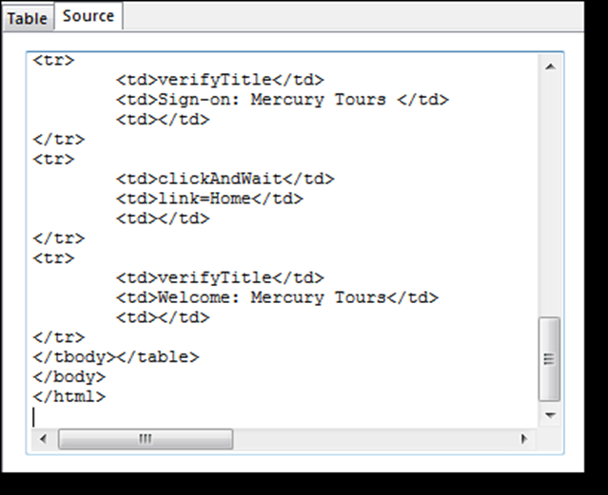

**Create a Script by Recording**

Let us now create our first test script in Selenium IDE using the most common method - by recording. Afterward, we shall execute our script using the playback feature.

Step 1

1. Launch Firefox and Selenium IDE.
2. Type the value for our Base URL: http://newtours.demoaut.com/
3. Toggle the Record button on (if it is not yet toggled on by default).

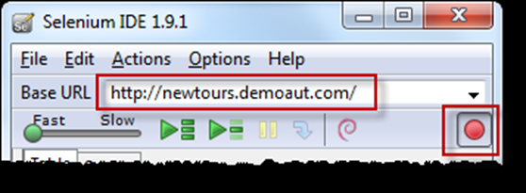

Step 2

In Firefox, navigate to http://http://newtours.demoaut.com/. Firefox should take you to the page similar to the one shown below.

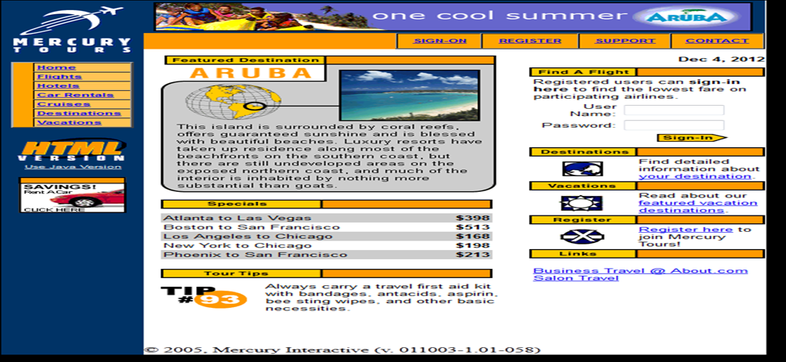

Step 3

* In the "User Name" text box of Mercury Tours, type an invalid username, "invalidUNN".
* In the "Password" text box, type an invalid password, "invalidPWD".

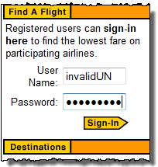 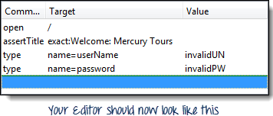

Step 4

* Click on the "Sign-In" button. Firefox should take you to this page.

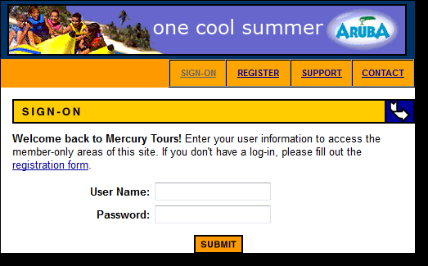

Step 5

* Toggle the record button off to stop recording. Your script should now look like the one shown below

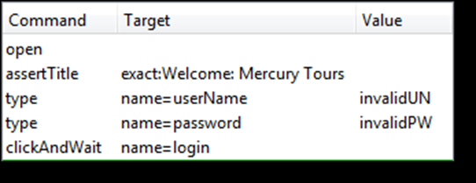

Step 6

* Now that we are done with our test script, we shall save it in a test case. In the File menu, select "Save Test Case". Alternatively, you can simply press Ctrl+S.

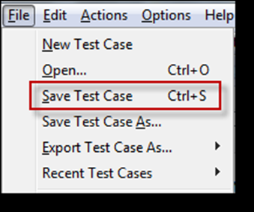

Step 7

* Choose your desired location, and then name the Test Case as "Invalid_login".
* Click the "Save" button.

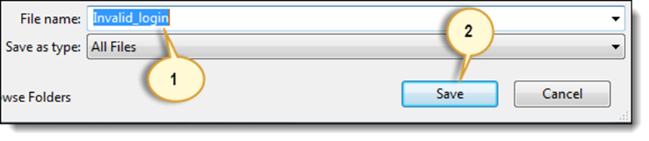

Step 9.

* Notice that the file was saved as HTML.

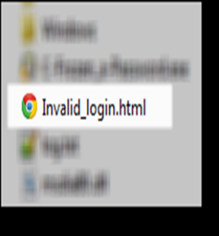

Step 10.

* Go back to Selenium IDE and click the Playback button to execute the whole script. Selenium IDE should be able to replicate everything flawlessly.

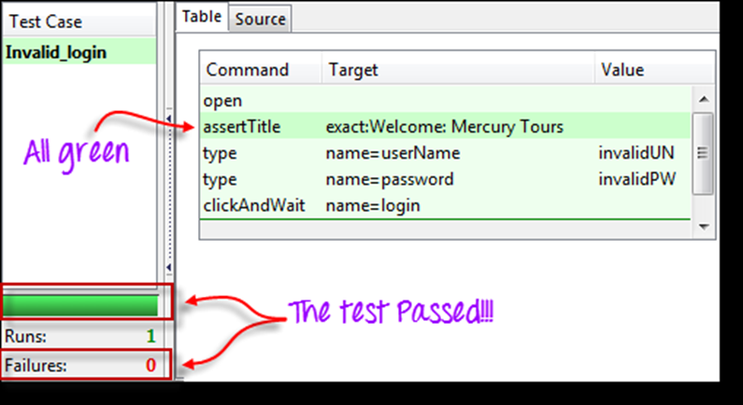

**Introduction to Selenium Commands – Selenese**

3 Types of Commands

|  |  |
| --- | --- |
| Actions | These are commands that directly interact with page elements.  Example: the "click" command is an action because you directly interact with the element you are clicking at.  The "type" command is also an action because you are putting values into a text box, and the text box shows them to you in return. There is a two-way interaction between you and the text box. |
| Accessors | They are commands that allow you to store values to a variable.  Example: the "storeTitle" command is an accessor because it only "reads" the page title and saves it in a variable. It does not interact with any element on the page. |
| Assertions | They are commands that verify if a certain condition is met.  3 Types of Assertions   * Assert. When an "assert" command fails, the test is stopped immediately. * Verify. When a "verify" command fails, Selenium IDE logs this failure and continues with the test execution. * WaitFor. Before proceeding to the next command, "waitFor" commands will first wait for a certain condition to become true.   + If the condition becomes true within the waiting period, the step passes.   + If the condition does not become true, the step fails. Failure is logged, and test execution proceeds to the next command.   + By default, the timeout value is set to 30 seconds. You can change this in the Selenium IDE Options dialog under the General tab. |

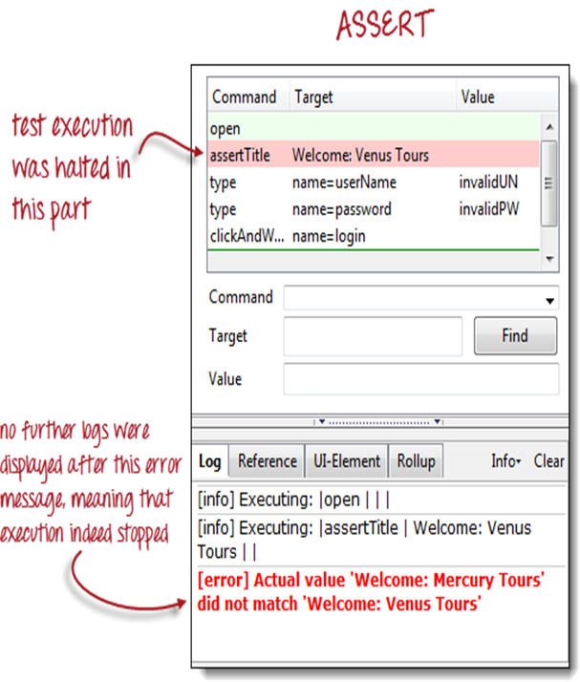Assert vs. Verify

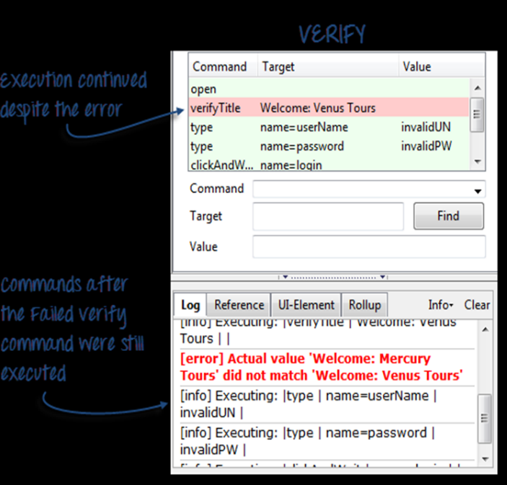

**Common Commands**

* **open -** Opens a page using a URL.
* **click/clickAndWait -** Clicks on a specified element.
* **type/typeKeys -** Types a sequence of characters.
* **verifyTitle/assertTitle -** Compares the actual page title with an expected value.
* **verifyTextPresent -** Checks if a certain text is found within the page.
* **verifyElementPresent -** Checks the presence of a certain element.
* **verifyTable -** Compares the contents of a table with expected values.
* **waitForPageToLoad -** Pauses execution until the page is loaded completely.
* waitForElementPresent

**Create a Script Manually with Firebug**

Now, we shall recreate the same test case manually, by typing in the commands. This time, we will need to use Firebug.

**Step 1**

* Open Firefox and Selenium IDE.
* Type the base URL (http://http://newtours.demoaut.com/).
* The record button should be OFF.

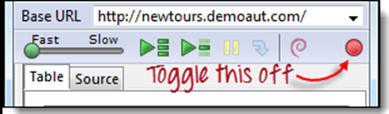

**Step 2**

* Click on the topmost blank line in the Editor.

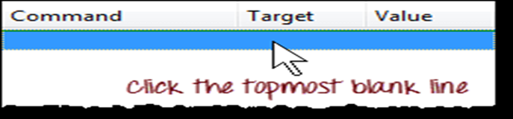

* Type "open" in the Command text box and press Enter.

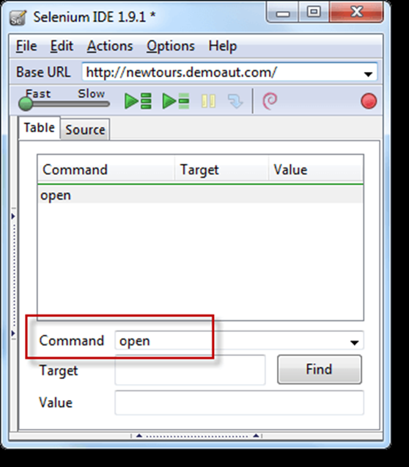

**Step 3**

* Navigate Firefox to our base URL and activate Firebug
* In the Selenium IDE Editor pane, select the second line (the line below the "open" command) and create the second command by typing "assertTitle" on the Command box.
* Feel free to use the autocomplete feature.

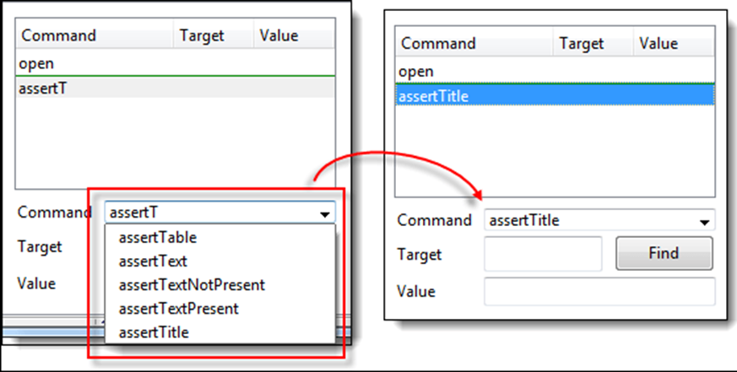

**Step 4**

* In Firebug, expand the <head> tag to display the <title> tag.
* Click on the value of the <title> tag (which is "Welcome: Mercury Tours") and paste it onto the Target field in the Editor.

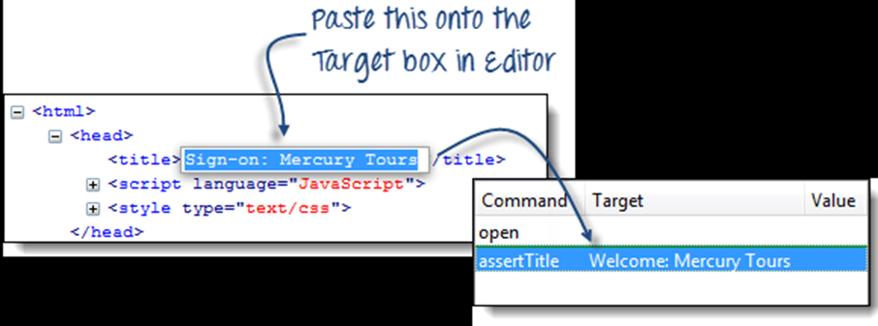

**Step 5**

* To create the third command, click on the third blank line in the Editor and key-in "type" on the Command text box.
* In Firebug, click on the "Inspect" button.

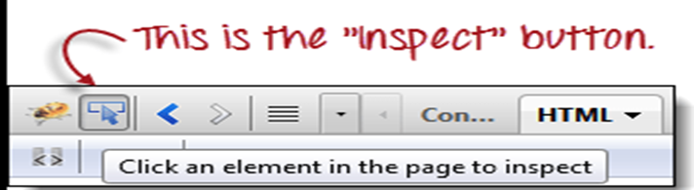

* Click on the User Name text box. Notice that Firebug automatically shows you the HTML code for that element.

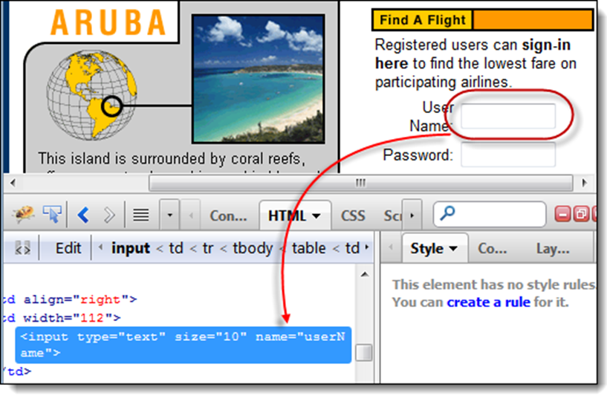

**Step 6**

* Notice that the User Name text box does not have an ID, but it has a NAME attribute. We shall, therefore, use its NAME as the locator. Copy the NAME value and paste it onto the Target field in Selenium IDE.

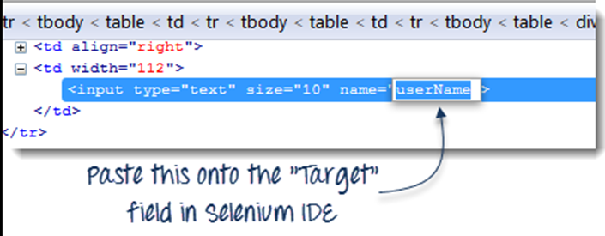

* Still in the Target text box, prefix "userName" with "name=", indicating that Selenium IDE should target an element whose NAME attribute is "userName."

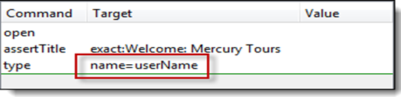

* Type "invalidUN" in the Value text box of Selenium IDE. Your test script should now look like the image below. We are done with the third command. Note: Instead of invalidUN, you may enter any other text string. But Selenium IDE is case sensitive, and you type values/attributes exactly like in the application.

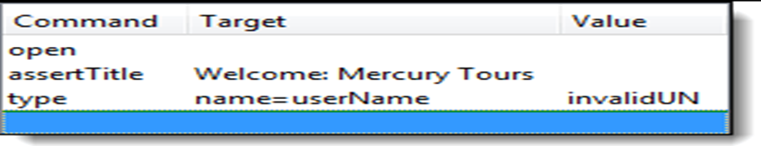

**Step 7**

* To create the fourth command, key-in "type" on the Command text box.
* Again, use Firebug's "Inspect" button to get the locator for the "Password" text box.

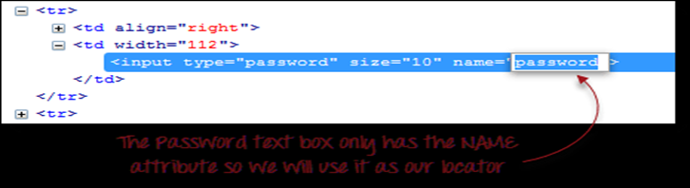

* Paste the NAME attribute ("password") onto the Target field and prefix it with "name="
* Type "invalidPW" in the Value field in Selenium IDE. Your test script should now look like the image below.

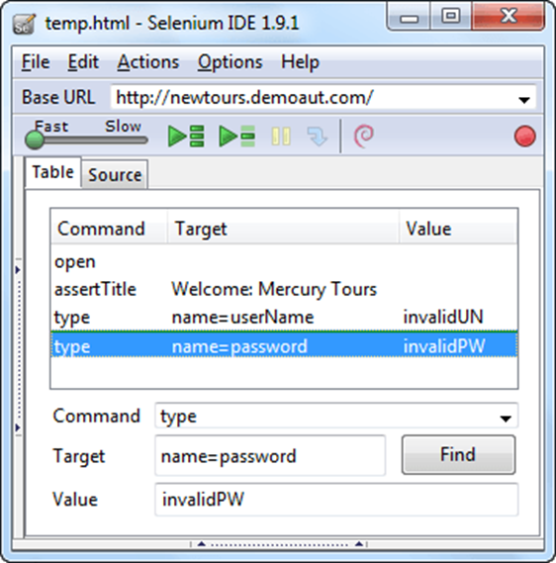

**Step 8**

* For the fifth command, type "clickAndWait" on the Command text box in Selenium IDE.
* Use Firebug's "Inspect" button to get the locator for the "Sign In" button.

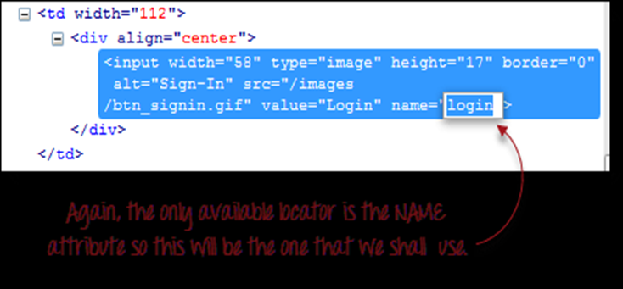

* Paste the value of the NAME attribute ("login") onto the Target text box and prefix it with "name=".
* Your test script should now look like the image below.

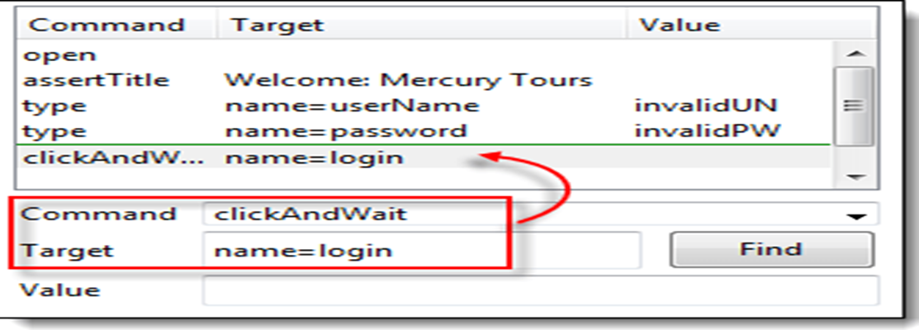

**How to use Locators in Selenium IDE**

Locator is a command that tells Selenium IDE which GUI elements (say Text Box, Buttons, Check Boxes etc) its needs to operate on.  Identification of correct GUI elements is a prerequisite to creating an automation script.

Selenium provides a number of Locators:

ID

Name

Link Text

CSS Selector - Tag and ID, Tag and class, Tag and attribute, Tag, class, and attribute Inner text

DOM (Document Object Model) – getElementById, getElementsByName, dom:name

dom: index

XPath

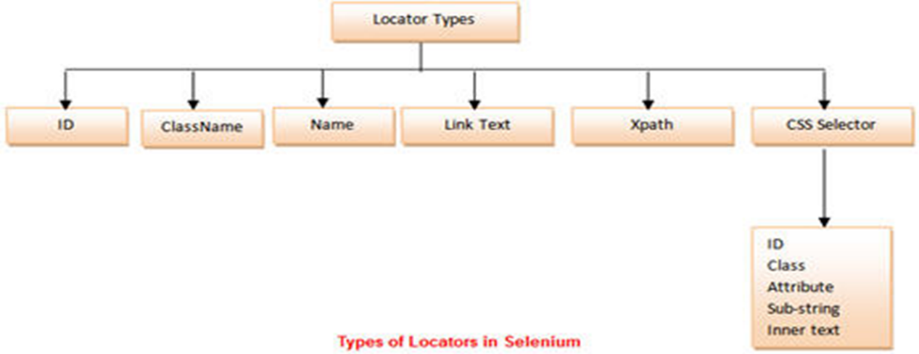

**Locating by ID**

This is the most common way of locating elements since ID's are supposed to be unique for each element.

Target Format: id=id of the element

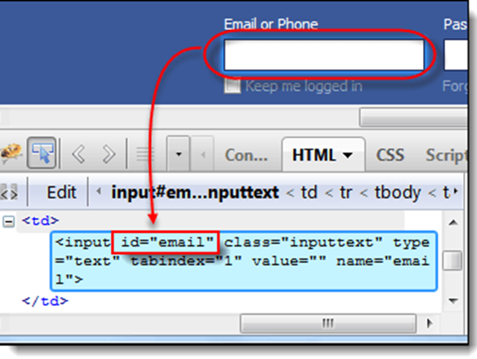

**Locating by Name**

* **Locating by Name using Filters**

Filters can be used when multiple elements have the same name. Filters are additional attributes used to distinguish elements with the same name.

Target Format: name=name_of_the_element filter=value_of_filter

* **Locating by Link Text**

This type of locator applies only to hyperlink texts. We access the link by prefixing our target with "link=" and then followed by the hyperlink text.

Target Format: link=link_text

* **Locating by CSS Selector**
* CSS Selectors are string patterns used to identify an element based on a combination of HTML tag, id, class, and attributes.
* Locating by CSS Selector is more complicated than the previous methods, but it is the most common locating strategy of advanced Selenium users because it can access even those elements that have no ID or name.
* Locating by CSS Selector - Tag and ID
* Syntax : css=tag#id
  + - tag = the HTML tag of the element being accessed
    - # = the hash sign. This should always be present when using a CSS Selector with ID
    - id = the ID of the element being accessed

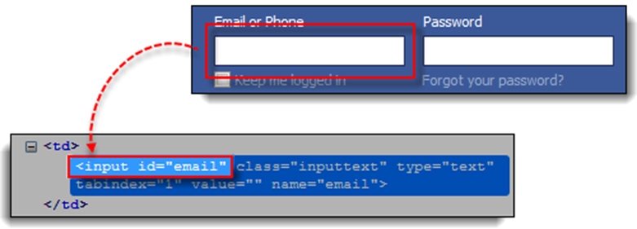

css=input#email

* **Locating by CSS Selector - Tag and Class**
* Locating by CSS Selector using an HTML tag and a class name is similar to using a tag and ID, but in this case, a dot (.) is used instead of a hash sign.
* Syntax : css=tag.class

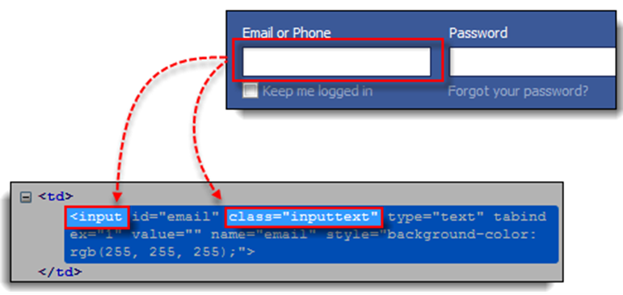

css=input.inputtext

* **Locating by CSS Selector - Tag and Attribute**
* This strategy uses the HTML tag and a specific attribute of the element to be accessed.
* Syntax: css=tag[attribute=value]

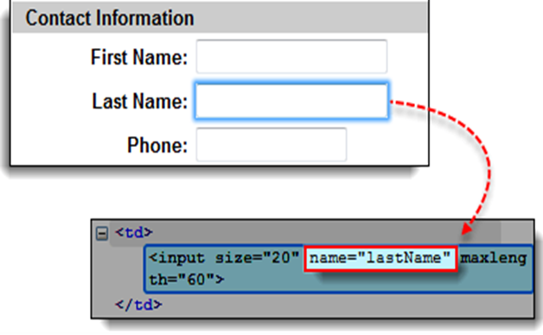

css=input[name=lastName]

* **Locating by CSS Selector - tag, class, and attribute**
* This strategy uses the HTML tag and a specific attribute of the element to be accessed.
* Syntax : css=tag.class[attribute=value]

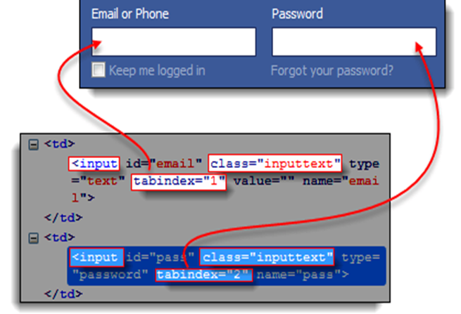

css=input[name=lastName]

* **Locating by CSS Selector - inner text**
* Syntax : css=tag:contains("inner text")

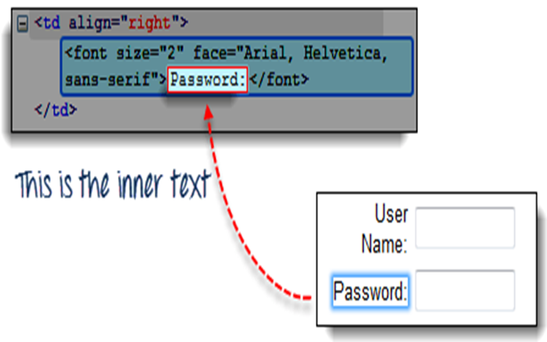

css=font:contains("Password:")

* **Locating by XPath**XPath is the language used when locating XML (Extensible Markup Language) nodes. Since HTML can be thought of as an implementation of XML, we can also use[XPath](https://www.guru99.com/xpath-selenium.html)in locating HTML elements.
* **Xpath can be created in two ways:**
  + **Relative Xpath**

Relative Xpath begins from the current location and is prefixed with a “//”.

For example: //span[@class=’Email’]

* + **Absolute Xpath**

Absolute Xpath begins with a root path and is prefixed with a “/”.

For example: /HTML/body/div/div[@id=’Email’]

* **Advantage:**It can access almost any element, even those without class, name, or id attributes.
* **Disadvantage:**It is the most complicated method of identifying elements because of too many different rules and considerations.
* Fortunately, Firebug can automatically generate XPath locators.
* In the following example, we will access an image that cannot possibly be accessed through the methods we discussed earlier.
* **Step 1.**Navigate to Mercury Tours Homepage and use Firebug to inspect the orange rectangle to the right of the yellow "Links" box. Refer to the image below.

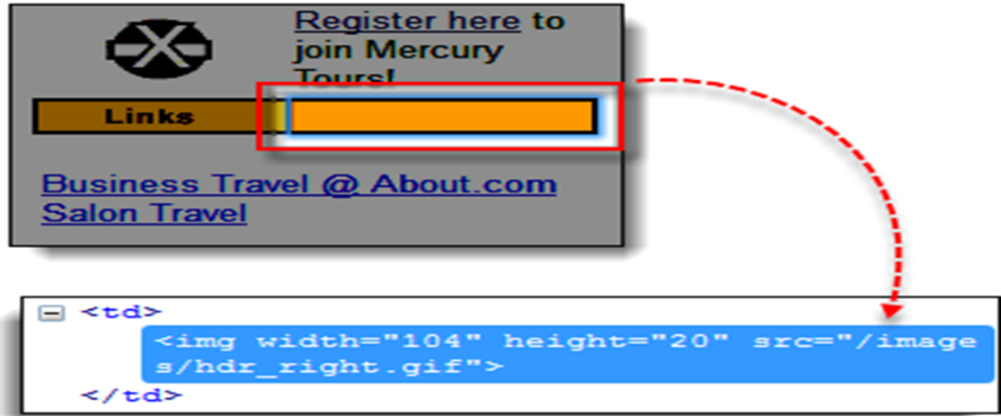

* **Step 2.** Right click on the element's HTML code and then select the "Copy XPath" option.  
  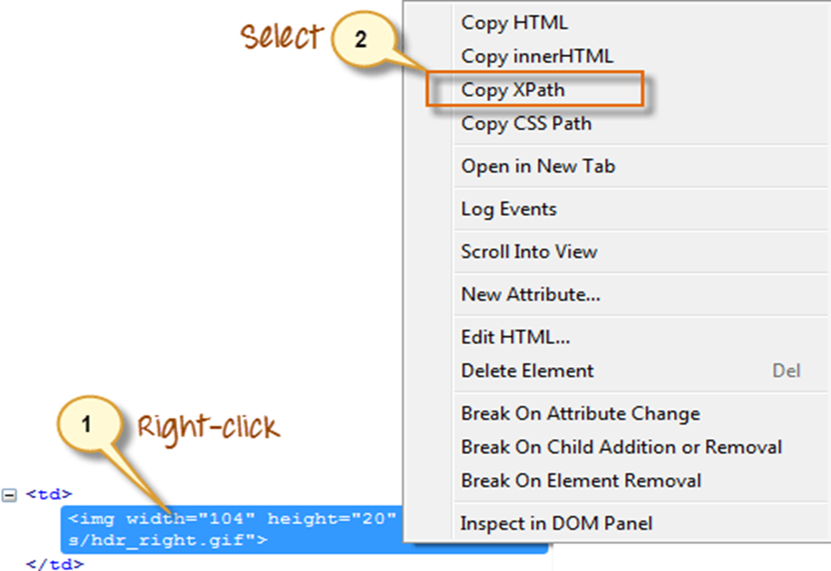
* **Step 3.**In Selenium IDE, type one forward slash "/" in the Target box then paste the XPath that we copied in the previous step. The entry in your Target box should now begin with two forward slashes "//".

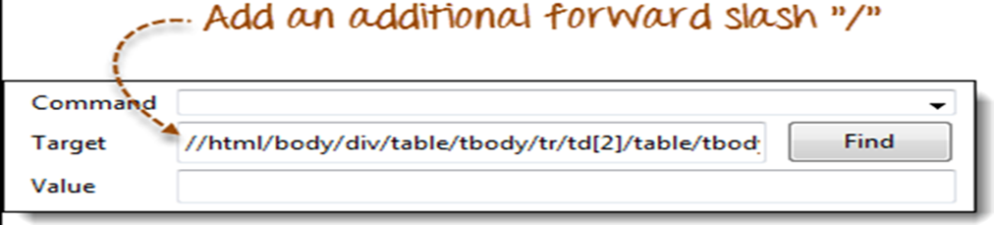

* **Step 4.** Click on the Find button. Selenium IDE should be able to highlight the orange box as shown below.

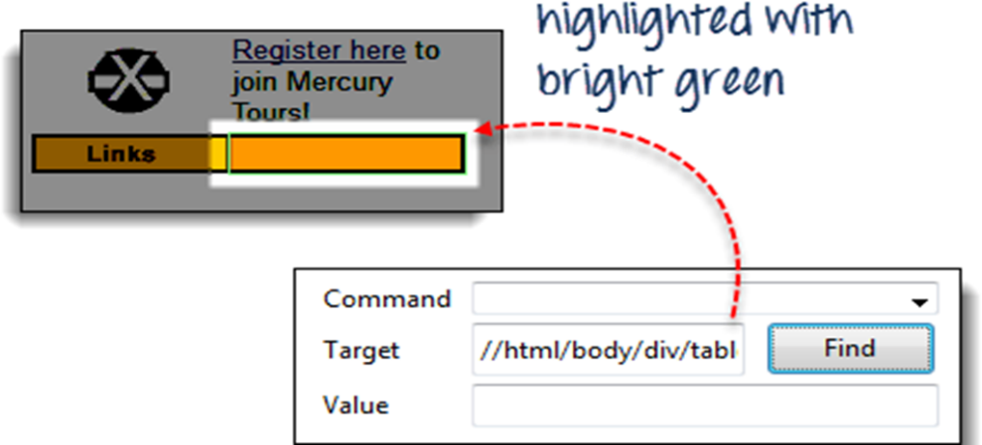

* **Creating a Xpath of a web element**
  + **Step 1:** Type “//img[@class=’logo’]” i.e. the locator value in the target box within the Selenium IDE.
  + Syntax: Xpath of the element
  + **Step 2:** Click on the Find Button. Notice that the image would be highlighted with yellow colour with a fluorescent green border around the field.

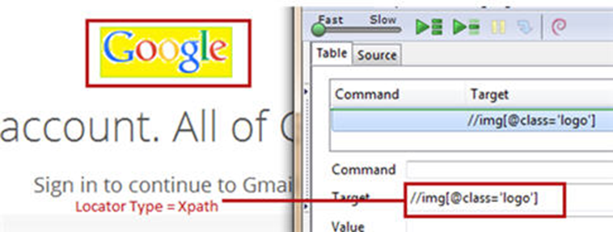

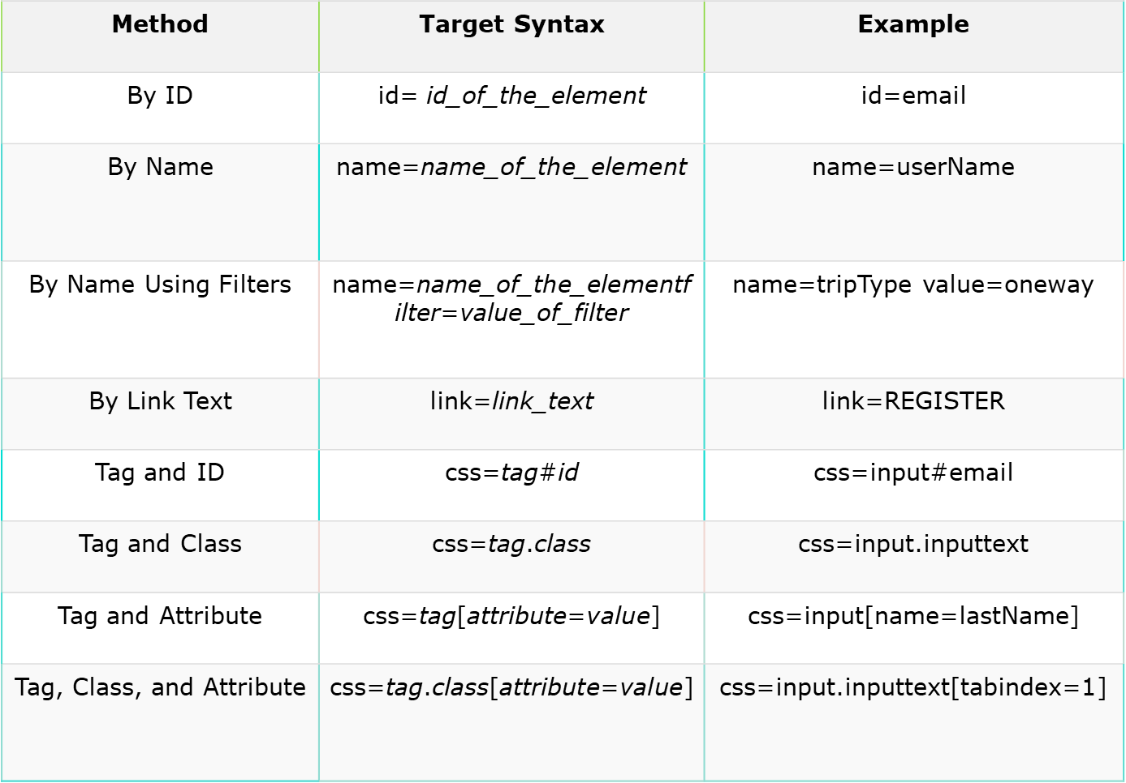

**Storing Variables and the Echo command**

* **Store**
  + To store variables in Selenium IDE, we use the "store" command. The illustration below stores the value "tutorial" to a variable named "myVariable."

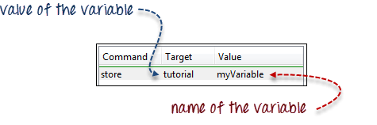

* + To access the variable, simply enclose it in a ${ ... } symbol. For example, to enter the value of "myVariable" onto the "userName" textbox of Mercury Tours, enter ${myVariable} in the Value field.

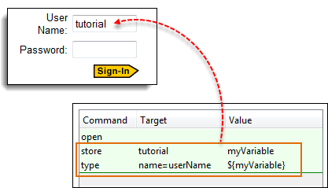

* + **StoreElementPresent**

This command stores either "true" or "false" depending on the presence of the specified element. The script below stores the Boolean value "true" to "var1" and "false" to "var2". To verify, we will use the "echo" command to display the values of var1 and var2. The Base URL for the illustration below was set to Mercury Tours homepage.

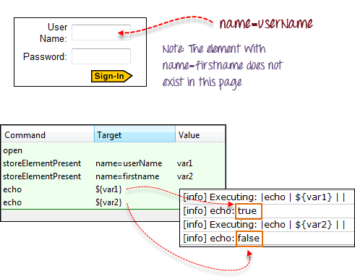

* + **StoreText**

This command is used to store the inner text of an element onto a variable. The illustration below stores the inner text of the tag in Facebook onto a variable named 'textVar.'

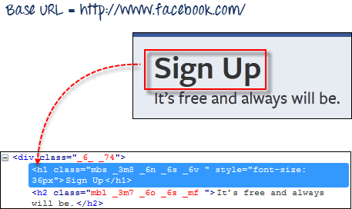

Since it is the only element in the page, it is safe to use 'css=h1' as our target. The image below shows that Selenium IDE was able to save the string "Sign Up" in the 'textVar' variable by printing its value correctly.

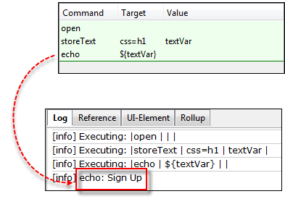

**Alerts, Popup, and Multiple Windows**

* Alerts are probably the simplest form of pop-up windows. The most common Selenium IDE commands used in handling alerts are the following:

|  |  |
| --- | --- |
| **Commands for Alerts** | **Description** |
| assertAlert assertNotAlert | retrieves the message of the alert and asserts it to a string value that you specified |
| assertAlertPresent  assertAlertNotPresent | asserts if an Alert is present or not |
| storeAlert | retrieves the alert message and stores it in a variable that you will specify |
| storeAlertPresent | returns TRUE if an alert is present; FALSE if otherwise |
| verifyAlert verifyNotAlert | retrieves the message of the alert and verifies if it is equal to the string value that you specified |
| verifyAlertPresent  verifyAlertNotPresent | verifies if an Alert is present or not |

Remember these two things when working with alerts:

1. Selenium IDE will automatically click on the OK button of the alert window, and so you will not be able to see the actual alert.
2. Selenium IDE will not be able to handle alerts that are within the page's onload() function. It will only be able to handle alerts that are generated after the page has completely loaded.

In this example, we will use the storeAlert command to show that even though Selenium IDE did not show the actual alert, it was still able to retrieve its message.

**Step 1.** In Selenium IDE, set the Base URL to http://jsbin.com. & the full url is: http://jsbin.com/usidix

**Step 2.** Create the script as shown below.

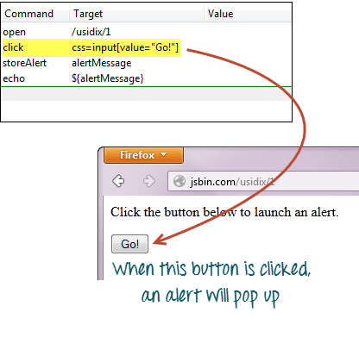

**Step 3.** Execute the script and do not expect that you will be able to see the actual alert.

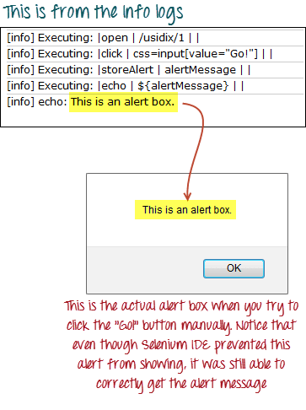

**Confirmations**

Confirmations are popups that give you an OK and a CANCEL button, as opposed to alerts which give you only the OK button. The commands you can use in handling confirmations are similar to those in handling alerts.

* assertConfirmation/assertNotConfirmation
* assertConfirmationPresent/assertConfirmationNotPresent
* storeConfirmation
* storeConfirmationPresent
* verifyConfirmation/verifyNotConfirmation
* verifyConfirmationPresent/verifyConfirmationNotPresent

However, these are the additional commands that you need to use to instruct Selenium which option to choose, whether the OK or the CANCEL button.

* chooseOkOnNextConfirmation/chooseOkOnNextConfirmationAndWait
* chooseCancelOnNextConfirmation

You should use these commands before a command that triggers the confirmation box so that Selenium IDE will know beforehand which option to choose. Again, you will not be able to see the actual confirmation box during script execution.

Let us test a webpage that has a button that was coded to show whether the user had pressed the OK or the CANCEL button.

**Step 1**. In Selenium IDE, set the Base URL to http://jsbin.com & the full url is: http://jsbin.com/enifaf

**Step 2.** Create the script as shown below. This time, we will press the OK button first.

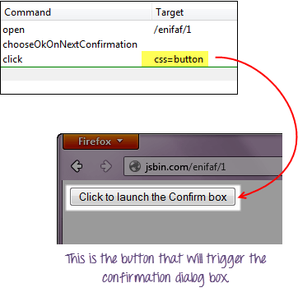

**Step 3.** Execute the script and notice that you do not see the actual confirmation, but the webpage was able to indicate which button Selenium IDE had pressed.

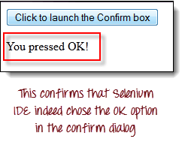

**Step 4.** Replace the "chooseOkOnNextConfirmation" command with chooseCancelOnNextConfirmation" and execute the script again.

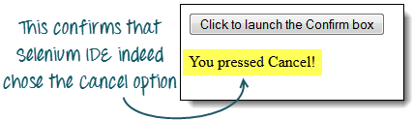

**Multiple Windows**

If you happen to click on a link that launches a separate window, you must first instruct Selenium IDE to select that window first before you could access the elements within it. To do this, you will use the window's title as its locator.

We use the selectWindow command in switching between windows.

We will use a link http://jsbin.com/ocinaj/1 whose title is "First Window." The "here" hyperlink found on that page will open Facebook in a new window, after which we shall instruct Selenium IDE to do the following:

Transfer control from the parent window to the newly launched Facebook window using the "selectWindow" command and its title as the locator

Verify the title of the new window

Select back the original window using the "selectWindow" command and "null" as its target.

Verify the title of the currently selected window

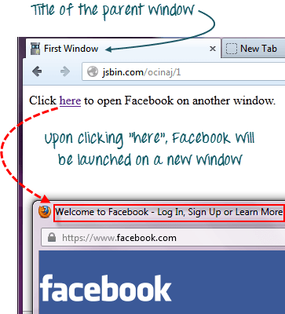

**Step 1.** Set the Base URL to http://jsbin.com.

**Step 2.** Create the script as shown below.

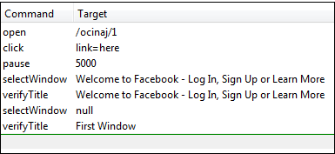

We need the "pause" command to wait for the newly launched window to load before we could access its title.

**Step 3.** Execute the script. Notice that the Test Case passed, meaning that we were able to switch between windows and verify their titles successfully.

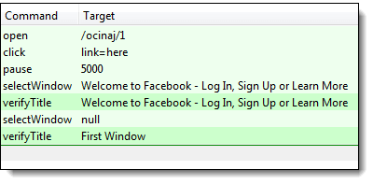

Always remember that setting selectWindow's target to "null" will automatically select the parent window (in this case, the window where the element "link=here" is found)

**Note: Facebook has changed the title since the creation of Tutorials. Please modify the code accordingly**